

Macclesfield, Cheshire SK10 2BN

DECLARATION OF CONFORMANCE

DoC Nº: JCI/FSDALIHEPT

Product Type: | Aluminium Bifold Triple Glazed Door
Intended Use: | For use in domestic and commercial premises  Not intended for use on escape route
Declared System of Assessment Performance: | 3
Provisions to which the Product Conforms: | Annex ZA of EN 14351-1:2006+A2:2016
Reference to Supporting Product Certification and/or Test Reports (supportive of compliance): | Exova - Weather Tightness Report: WIL 383704 Rosenheim - Thermal Performance Report:12-000309-PRO1
Declared Performance:  Essential Characteristics | Performance
Resistance to Wind Load: | Class B3 (1200Pa)
Watertightness: | Class 4A (150Pa)
Dangerous Substance: | No emissions of dangerous substances emitted
Load Bearing Capacity of Safety Device: | Npd
Acoustic Performance | Npd
Thermal Transmittance: | 1.0w/(m²K)
Radiation Properties: | Npd
Air Permeability: | Class 6 (600Pa)
This declaration of performance is issued under the sole responsibility of JCI Limited.

Signed for and on behalf of the Company by

Name of Representative: John Collins Job Title: Managing Director

Representative Signature: 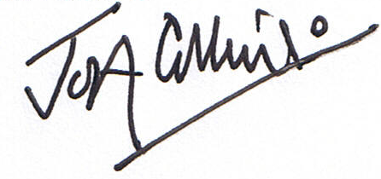 Date of Issue: 1st June 2022

Product CE Marking Detail:


JCI Limited

Macclesfield. SK10 2BN

19

EN 14351-1:2006+A2:2016

Aluminium Bifold Triple Glazed Door

DoC Nº: JCI/FSDALIHEPT

Not intended for use on escape route

